NEW FILE TRANSFER SYSTEM LAUNCHES THIS WEEK FOR BROWN EDWARDS FORMERLY MITCHELL WIGGINS CPAS

With the transition to Brown Edwards, we have an exciting update to the way tax clients will transmit files securely to us. Our new file transfer system, Share Safe, does not require a username, password or two-step verification. We hope that you will find this system easier to use than previous portals. To help in the transition to this new option, we are providing some answers to frequently asked questions.
Who will use it?
For our clients that receive audited, reviewed, or compiled financial statements from Brown Edwards, you will continue to use the method of transmission communicated to you by your engagement team.
For our clients that are only receiving tax services, instead of the Doc.It portal, you will now use the secure file transfer described below. The Doc.it portal, will be taken offline February 11, 2022. We ask, if you have not already done so, please download any information you will need before that time.
How do I access Share Safe?
You can use the link below to access this site. Please save this as a “favorite” or a bookmark within your internet browser for easy access in the future. This link can also be found in our accountants’ email signatures.
https://www.clientaxcess.com/sharesafe/#/BrownEdwards
How do I transfer data?
On the initial screen, please fill out as much information as possible and if you are sending information for a Company, please include the Company name(s) that is associated with the documents.

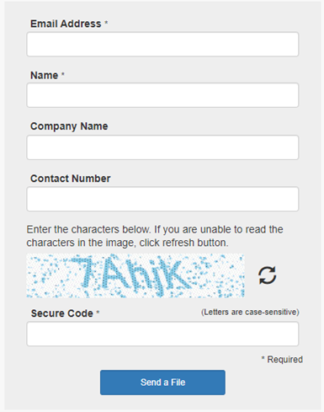

Once your information is added, click “Send a File”. The following screen will allow you to select the individual at Brown Edwards you wish to send the information. A subject, message and file(s) are required before you are allowed to send your file(s). The files are added by clicking the “Add Files” button. Once all information is complete, click on “Send” to transmit your files securely to Brown Edwards.
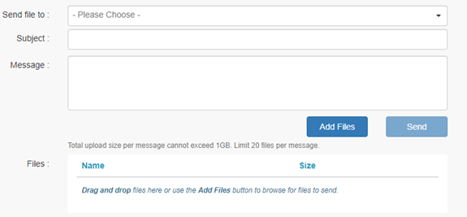

When can I use it?
We are very excited about this new option for transmitting files electronically and it is available to use now.
When should I upload my tax documents?
For tax return clients uploading year-end tax information, we respectfully request that you gather 80% to 90% of your tax documents and information before sending it to us. This will allow us to provide more efficient and timely service to you as we work towards the filing deadlines.
Who can I reach out to with questions?
If you have any questions or concerns regarding the transition, please contact one of the administrators.
Richmond Office
Leslie Johnson
ljohnson@becpas.com
804-591-2582
Petersburg Office
Ruth Yorston
ryorston@becpas.com
804-733-5566

