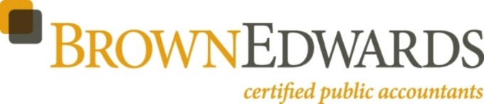

2018 COST-OF-LIVING ADJUSTMENTS FOR QUALIFIED RETIREMENT PLANS

The Internal Revenue Service has announced the cost-of-living adjustment (COLA) for 2018. The dollar limitations for pension plans and selected other items are listed below. Certain annual compensation amounts were increased, including the limit for elective deferrals, which have not been updated since 2015. The Social Security Administration separately announced an increase to the taxable wage base2.

Code Section | 2018 | 2017 | 2016 | 2015 | 2014
401(a)(17)/404(l) Annual Compensation | $275,000 | $270,000 | $265,000 | $265,000 | $260,000
402(g)(1) Elective Deferrals | 18,500 | 18,000 | 18,000 | 18,000 | 17,500
408(k)(2)(C) SEP Minimum Compensation | 600 | 600 | 600 | 600 | 550
408(k)(3)(C) SEP Maximum Compensation | 275,000 | 270,000 | 265,000 | 265,000 | 260,000
408(p)(2)(E) SIMPLE Maximum Contributions | 12,500 | 12,500 | 12,500 | 12,500 | 12,000
409(o)(1)(C) ESOP Limits | 1,105,000  220,000 | 1,080,000  215,000 | 1,070,000  210,000 | 1,070,000  210,000 | 1,050,000  210,000
414(q)(1)(B) HCE Threshold | 120,000 | 120,000 | 120,000 | 120,000 | 115,000
414(v)(2)(B)(i) Catch-up Contributions | 6,000 | 6,000 | 6,000 | 6,000 | 5,500
414(v)(2)(B)(ii) Catch-up Contributions | 3,000 | 3,000 | 3,000 | 3,000 | 2,500
415(b)(1)(A) DB Limits | 220,000 | 215,000 | 210,000 | 210,000 | 210,000
415(c)(1)(A) DC Limits | 55,000 | 54,000 | 53,000 | 53,000 | 52,000
416(i)(1)(A)(i) Key Employee | 175,000 | 175,000 | 170,000 | 170,000 | 170,000
457(e)(15) Deferral Limits | 18,500 | 18,000 | 18,000 | 18,000 | 17,500
1.61-21(f)(5)(i) Control Employee | 110,000 | 105,000 | 105,000 | 105,000 | 105,000
1.61-21(f)(5)(iii) Control Employee | 220,000 | 215,000 | 215,000 | 215,000 | 210,000
219(b)(5)(A) IRA Contribution Limit | 5,500 | 5,500 | 5,500 | 5,500 | 5,500
219(b)(5)(B) IRA Catch-Up Contributions | 1,000 | 1,000 | 1,000 | 1,000 | 1,000
Taxable Wage Base for Social Security | 128,700 | 127,200 | 118,500 | 118,500 | 117,000

